When you record an online meeting, you capture audio, video, instant messaging (IM), screen sharing, PowerPoint slides, whiteboard, and polling. Any of the presenters can record a meeting and save it on their computers.

## Record your online meeting

1. Click **More Options** Screen shot of the more options button> **Start Recording**.

If the recording option is dimmed, your audio might not be connected. Click the mic/phone icon to connect audio, then try again.

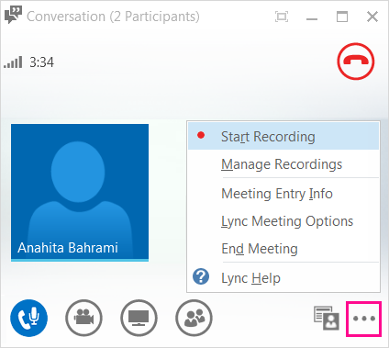

TIP: To reduce the file size of the recording, go to **Tools** > **Options** > **Recordings** to change the Image Resolution.

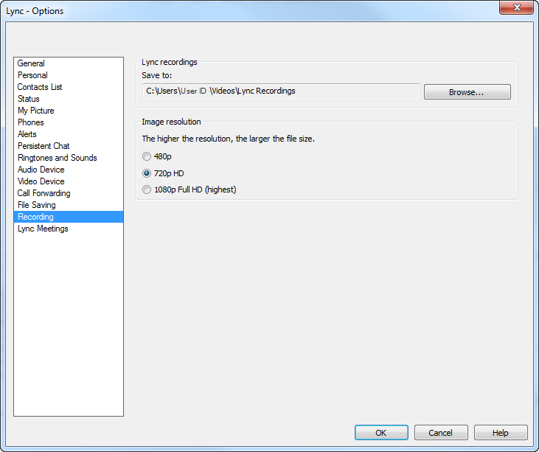

1. Use the controls at the bottom of the meeting to pause, resume, or stop the recording.

Screen shot of recording controls

1. To see who else is recording, point to the red recording button.
2. 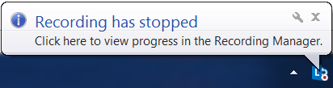When you’re done, click **Stop Recording**.
3. Skype automatically saves the recording in MP4 format that plays in Windows Media Player**.** You can exit the meeting while the recording is being processed.

* Presenters should tell attendees that the session is being recorded.
* Mask confidential information when recording.
* Attendees should notify the presenter if they have concerns about a session being recorded.

## Play and share a recording

When your recording has been processed, you can access it to play or send to others. Skype displays a message when the recording is ready. You can click the alert to open **Recording Manager**, or if you miss that, click **Tools** on the Skype main window, then **Recording Manager**.

In the **Recording Manager** window:

1. Click your recording to highlight it, then click **Play** on the right side of the window.
2. You can also rename or delete your recording here.
3. To share your recording with others, click **Browse** to locate it, then copy the file to publish or upload to the desired location.

 Tip:    Recordings are saved in the **Videos**/**Skype Recordings** folder on your computer.

## Recording manager

Use the **Recording Manager** to play your recordings, browse to the location you saved them, or publish with selected options for others to view. You can also rename or delete your recordings.

**Manage your recordings**

1. To access the **Recording Manager**, click **Tools** on the main window and then click **Recording Manager**. You can also open the Recording Manager from inside a meeting.
2. Highlight a recording and do one of the following:

* To play the recording click **Play**. The video opens in **Windows Media Player**.
* Click **Browse** to go to the location of the recording.
* Click **Rename** and type a new name in the highlighted area.
* Click **Delete** to permanently remove the recording from your computer, (it won’t be sent to the **Recycle Bin**).
* **Publish** lets you rename the recording and save it to a different location. You can also click **Options** and select the type of the content you want to include in the recording, such as   
  IM, or video.

## Save and publish a recording

Use the **Save and Publish** options to rename or move your recording. You can also choose what to include in the recording, such as instant messages, participant or panoramic video.

**Save and Publish**

1. Open **Tools** > **Recording Manager**.
2. Highlight a recording and click **Publish**.
3. Type a new name for your recording in the **Recording file name** box.
4. To change the location of the recording, click **Browse** next to the **Save to** box, then go to the folder where you want to save the video.

By default, recordings include audio, video, IMs, and presented content, such as screen sharing and PowerPoint slides. If you want, you can remove some of the content from your recording:

1. Click **Options** and uncheck any of the content that you don’t want to keep.

* Audio
* Participants video
* Panorama video
* Instant message
* Presented content

After your click **OK**, your recording is saved in the new location and with the content you selected.   
Files are saved as .mp4 file type.

## Where to save recordings

If you want to share this video, you must publish the file in an accessible location for others to view it. Since files sizes can be very large, contact your IT Administrator for guidance.

**Are you thinking about creating communication or training content with the recording feature?**   
Online meeting recordings are not always the most optimal way to deliver training content since recorded files sizes are very large (e.g., a 30-minute recording can be more than 150 MB). Consider using PowerPoint to create and publish training instead. PowerPoint allows you to have better control over your content, and you can easily do the following:

* Create, edit and add audio files, including slide narrations.
* Add video files.
* Control your timing, slide transitions, animations and other features.
* Publish a read-only version, with a smaller file size.